GEOL 3305

Chapter 20

Climate

Climate System

- atmosphere, hydrosphere, solid Earth, biosphere, and cryosphere.

Components of Climate

Temperature
Precipitation

Temperature and Precipitation substantially influence
the vegetation and soils

Köppen Classification

is based on:
mean monthly temperature and precipitation
annual temperature and precipitation

The segmentation of the world was based on certain plant associations since they express the totality of climate.

Köppen Classification has 5 groups

Humid tropical
Dry
Humid middle-latitude - mild winters
Humid middle-latitude - severe winters
Polar

All groups except "Dry" are primarily based on temperature. "Dry" is based on precipitation.
Maximum temperature records (low elevation, deserts, low latitude)

Western hemisphere 57 oC Death Valley CA
World record 59 oC Azizia Libya
Antarctica 15 oC

Minimum temperature records (continental, near the poles, high altitude)

World record -89 oC in Vostok Antarctica
Asia -68 oC Oymykon, Russia (Siberia)
Greenland -66 oC
North America -63 oC Snag Yukon Canada

The hottest temperature recorded in Houston was 109 F deg on Sept 4, 2000 & tied Aug. 27, 2011.

The coldest temperature recorded in Houston was 5 F deg on Jan 23, 1930.

The best way to prepare for a long trip to a region you are unfamiliar with is to
obtain the daily weather conditions for the entire month that you will be in that location.

Here are the 5 groups in the Köppen Classification system

A-Humid Tropics (includes almost 10% of Earth's surface)
-Near the equator (no winter season)
-Elevations below 1000 m.
-Tropical Savanna is caused by a long dry season
which is the result of the annual shift of the equatorial
low pressure system (it follows the sun)

B-Dry
Low Latitude
-Coincides with the subtropical high-pressure belts
(tropics of Cancer and Capricorn)

Middle Latitude
-Cut off from moisture supply by mountains or distance
-Steppes - transition to more humid region.

C-Humid middle-latitude - mild winters
Humid Subtropics

Gulf Coast
Marine West Coast

Onshore ocean air in NW U.S. and Europe
Dry-Summer Subtropics
Mediterranean
West side of continents (30 to 45 deg latitude)

D-Humid Middle-Latitude (with severe winters)
(absent from the S. hemisphere due to oceans)
Humid continental
Eastern portions of N. America and Eurasia (40-50o N)

Subarctic (source regions of Arctic air)
taiga climate named after N. coniferous forests)

E-Polar (Meager precipitation - although very humid)

Tundra - treeless climate (high latitude, continental)
Ice cap - permanent ice and snow (mean monthly T < 0 oC)

Remember that weather systems moves west to East due to the jet stream blowing
the storms in that direction. In the winter when there is a Cold high pressure system
over Canada or Sieria, the air moves south also. So consequently the weather moves
south and east (southeast).

So we get Cold weather from Siberia in the winter, but it has to cross the pacific ocean and becomes much warmer and wetter. These are called Pacific fronts.

Cold weather from Canada doesn't move across an ocean, so it is much colder. These are called Polar fonts.

Human Impact on Global Climate

Fossil fuel burning since the civil war has increased atmospheric CO2 by 25%. About 10 petagrams (10¹⁶) (100 billion lbs) of Carbon are released by fossil fuel burning each year.

About half goes into the oceans and biosphere & half stays in the atmosphere.

Global average temperatures have risen by 0.5 oC since 1880.

Short Lived Climate Pollutants versus long lived Pollutants

CO2 has a long life span in the atmosphere

Short Lived Pollutants are just as important in terms of Climate Change

Black Carbon persists in the atmosphere only days to weeks

Methane persists for about a decade

HFC's (Hydro-Fluoro-Carbon Compounds) persist for about 15 years

Water vapor and Carbon Dioxide are largely responsible for most of the greenhouse effect.

Likely weather changes due to global warming

-Hurricanes
More often & greater intensity
-Cyclonic Storms
Shift of the paths - affects severe storms
-Heat waves and droughts
More often and greater intensity

Possible climate changes from doubling of CO2

-Global mean surface warming

-Global mean precipitation increase

-Reduction of sea ice

-Polar winter surface warming

-Summer continental dryness warming

-High-Latitude precipitation increase

-Rise in global mean sea level

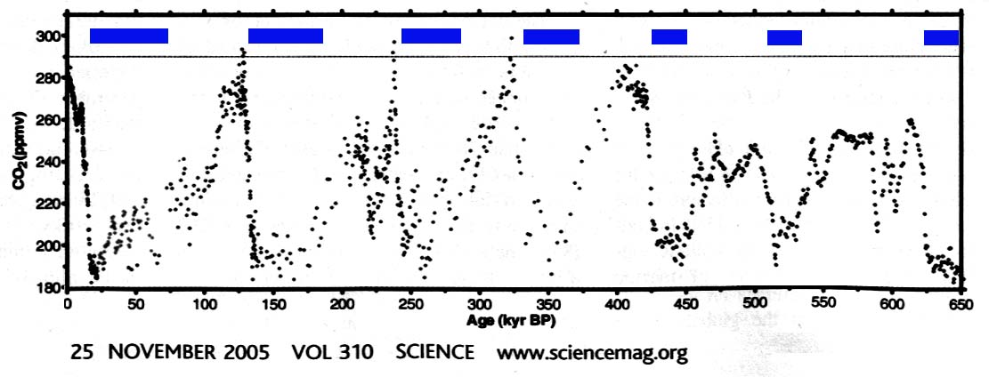

CO₂ records from 3 Antarctic ice cores showing ice ages (blue) only occurred when
Antarctic ice sheet formed 35 MY BP when CO₂ dropped below 750 ppm. Since then it only changed by 100 m.
Science 13 Aug 2010 pg 729

CO₂ records from 3 Antarctic ice cores showing ice ages (blue). Ice ages only form when Carbon Dioxide is low during the last 650,000 years.

Because the HFCs (Hydro-Fluorine-Carbon compounds such as Freon -113) have a stronger affect on global warming than anything else, replacement refrigerants are being considered: isobutane, propane, propylene, ammonia and even carbon dioxide.

Carbon Dioxide Concentrations at Mauna Loa, Hawaii show increases from 1973 to 2019

In 2019 we are now at 400 ppm (a level not seen for 3,000,000 years)
Each N.H. summer vegetation removes 10 billion tons of CO₂ making a lower concentration each summer.

Methane is increasing each year also.

Global Warming is causing the Alaskan permafrost to melt
Homes in Alaska are being threatened
Roads are being damaged
Dalton Highway is affected in 43 places
Energy infrastructure is being damage

Widespread drought occurred in the Amazon basin in 2005 making parts of the Amazon more like the Savanna.

For the third year in a row in 2007 the Earth's northern ice cap has shrunk alarmingly (less than 2,500,000 sq miles and still shrinking), ref. National Snow & Ice Center.

We are 30 years ahead of what the models show.
By 2050, there will be no arctic ice in the summer.
http://nsidc.org/arcticseaicenews/

Between 1992 and 2011
Antarctic ice sheets lost 1,320 +- 980 Gigatons of ice

Greenland ice sheets lost 2940 +- 940 Gigatons of ice
This resulted in a global mean sea level rise of 11.1 +-3.8 mm

Science Nov. 30, 2012 pg 1183

Urban Heat Island Effect

Buildings and trees increase friction and slow wind speeds.

Heat from buildings, cars, industry warm the air.

Added heat increases convection.

Exhaust of cars, industry, increases condensation nuclei.

All the above increases rainfall and makes storms move slower.

